**WEEK_2_TDD using JUnit5 and Mockito**

**Exercise 1: Setting Up Junit**

POM.XML

Add dependency

<dependencies>

<dependency>

<groupId>junit</groupId>

<artifactId>junit</artifactId>

<version>4.13.2</version>

<scope>test</scope>

</dependency>

</dependencies>

Calcuator.java

package com.example;

public class Calculator {

public int add(int a, int b) {

return a + b;

}

}

CalculatorTest – Junit test case

package com.example;

import static org.junit.Assert.*;

import org.junit.Test;

public class CalculatorTest {

*@Test*

public void testAdd() {

Calculator calc = new Calculator();

*assertEquals*(5, calc.add(2, 3));

}

}

**OUTPUT**

**Example 3- Assertions in JUnit**

package com.example;

import static org.junit.Assert.*;

import org.junit.Test;

public class AssertionsTest {

@Test

public void testAssertions() {

// Assert equals

assertEquals(5, 2 + 3);

// Assert true

assertTrue(5 > 3);

// Assert false

assertFalse(5 < 3);

// Assert null

assertNull(null);

// Assert not null

assertNotNull(new Object());

}

}

**Output**

**Exercise 4: Arrange-Act-Assert (AAA) Pattern, Test Fixtures, Setup and Teardown Methods in Junit**

**Calculator.java**

package com.example;

public class Calculator {

public int add(int a, int b) {

return a + b;

}

public int subtract(int a, int b) {

return a - b;

}

}

**CalculatorTest.java**

package com.example;

import static org.junit.Assert.*;

import org.junit.Before;

import org.junit.After;

import org.junit.Test;

public class CalculatorTest {

private Calculator calculator;

@Before

public void setUp() {

calculator = new Calculator();

System.out.println("Setup Complete");

}

@After

public void tearDown() {

System.out.println("Teardown Complete");

}

@Test

public void testAddition() {

int a = 5;

int b = 3;

int result = calculator.add(a, b);

assertEquals(8, result);

}

@Test

public void testSubtraction() {

int a = 10;

int b = 4;

int result = calculator.subtract(a, b);

assertEquals(6, result);

}

}

**POM.XML**

dependencies>

<dependency>

<groupId>junit</groupId>

<artifactId>junit</artifactId>

<version>4.13.2</version>

<scope>test</scope>

</dependency>

</dependencies>

**OUTPUT:**

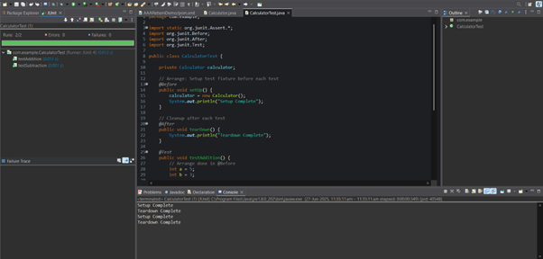

**MOCKITO**

**Exercise 1: Mocking and Stubbing**

**POM.XML**

<dependencies>

<!-- JUnit 5 -->

<dependency>

<groupId>org.junit.jupiter</groupId>

<artifactId>junit-jupiter</artifactId>

<version>5.9.3</version>

<scope>test</scope>

</dependency>

<!-- Mockito -->

<dependency>

<groupId>org.mockito</groupId>

<artifactId>mockito-core</artifactId>

<version>4.11.0</version>

<scope>test</scope>

</dependency>

</dependencies>

**ExternalApi.java**

package com.example;

public interface ExternalApi {

String getData();

}

**MyService.java**

package com.example;

public class MyService {

private ExternalApi api;

public MyService(ExternalApi api) {

this.api = api;

}

public String fetchData() {

return api.getData();

}}

**ServiceTest.java**

package com.example;

import static org.junit.jupiter.api.Assertions.assertEquals;

import static org.mockito.Mockito.*;

import org.junit.jupiter.api.Test;

import org.mockito.Mockito;

public class MyServiceTest {

@Test

public void testExternalApi() {

ExternalApi mockApi = Mockito.mock(ExternalApi.class);

when(mockApi.getData()).thenReturn("Mock Data");

MyService service = new MyService(mockApi);

String result = service.fetchData();

assertEquals("Mock Data", result);

}

}

**OUTPUT:**

**Exercise 2: Verifying Interactions**

**POM.XML**

<dependencies>

<!-- JUnit 5 -->

<dependency>

<groupId>org.junit.jupiter</groupId>

<artifactId>junit-jupiter</artifactId>

<version>5.9.3</version>

<scope>test</scope>

</dependency>

<!-- Mockito -->

<dependency>

<groupId>org.mockito</groupId>

<artifactId>mockito-core</artifactId>

<version>4.11.0</version>

<scope>test</scope>

</dependency>

</dependencies>

**ExternalApi.java**

package com.example;

public interface ExternalApi {

String getData();

}

**MyService.java**

package com.example;

public class MyService {

private ExternalApi api;

public MyService(ExternalApi api) {

this.api = api;

}

public String fetchData() {

return api.getData();

}

}

**ServiceTest.java**

package com.example;

import static org.mockito.Mockito.*;

import org.junit.jupiter.api.Test;

import org.mockito.Mockito;

public class MyServiceTest {

@Test

public void testVerifyInteraction() {

ExternalApi mockApi = Mockito.mock(ExternalApi.class);

MyService service = new MyService(mockApi);

service.fetchData();

verify(mockApi).getData();

}

}

**OUTPUT:**

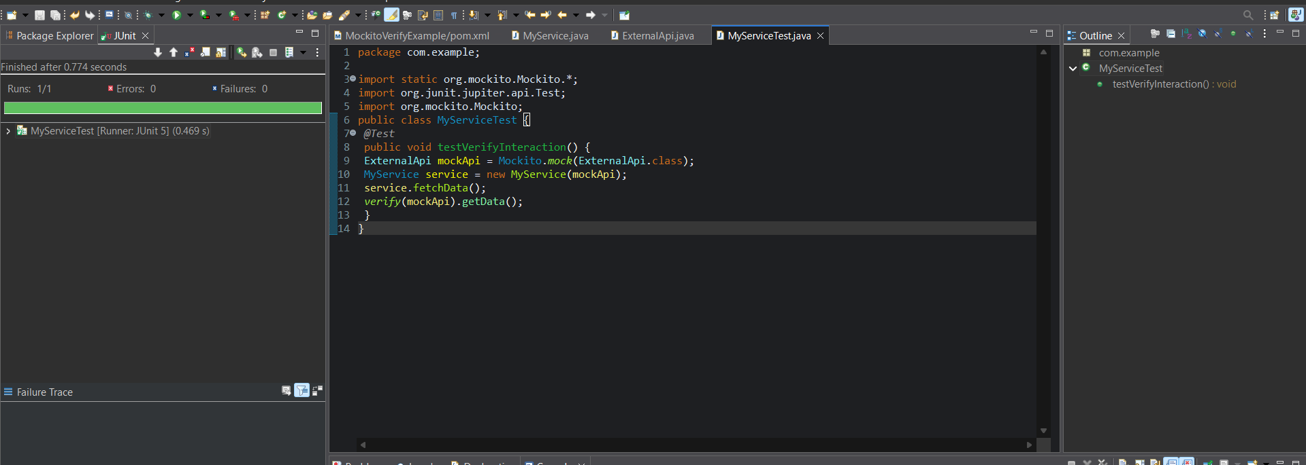

**Logging using SLF4J**

**Exercise 1: Logging Error Messages and Warning Levels Task: Write a Java application that demonstrates logging error messages and warning levels using SLF4J.**

Step-by-Step Solution:

1. Add SLF4J and Logback dependencies to your pom.xml file:

<dependencies>

<!-- SLF4J API -->

<dependency>

<groupId>org.slf4j</groupId>

<artifactId>slf4j-api</artifactId>

<version>1.7.30</version>

</dependency>

<!-- Logback as the backend implementation -->

<dependency>

<groupId>ch.qos.logback</groupId>

<artifactId>logback-classic</artifactId>

<version>1.2.3</version>

</dependency>

</dependencies>

2. Create a Java class that uses SLF4J for logging:

package com.example;

import org.slf4j.Logger;

import org.slf4j.LoggerFactory;

public class LoggingExample {

private static final Logger ***logger*** = LoggerFactory.*getLogger*(LoggingExample.class);

public static void main(String[] args) {

***logger***.error("This is an error message");

***logger***.warn("This is a warning message");

}

}

oUTPUT:

